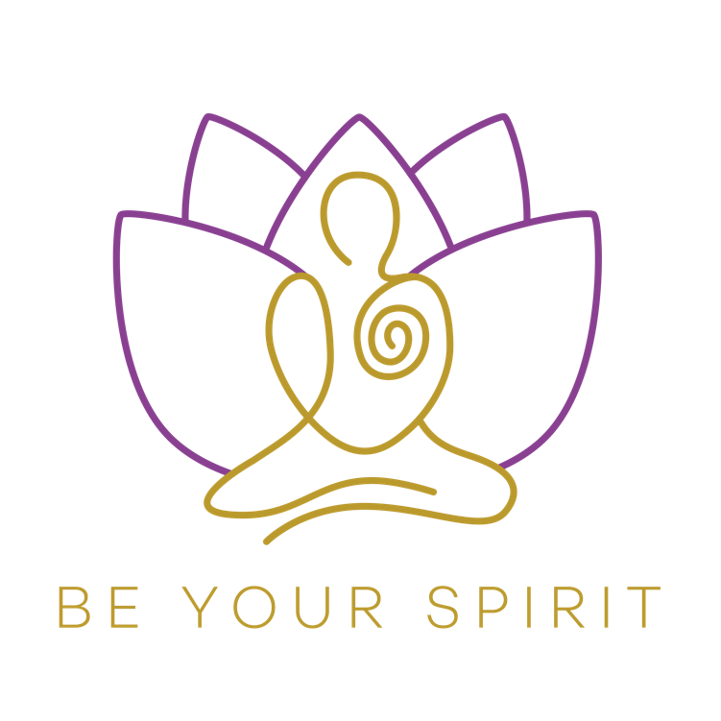

**100-Hour Transformational Meditation Teacher Training in Greece**

**This unique 100hour MTTC accredited by Yoga Alliance Professionals provides a full understanding of Meditation. Instead of past times meditation was linked to a religion and many courses would only teach one meditation type, this course provides a varied amount of different meditations to give a full range of meditations that you will be able to teach to others in modern day classes.**

Name of Course: 100Hour Transformational Meditation Teacher Training

Total Number of Hours on Course: 100 Hours

Starts online 4 weeks before (18th August) we meet in Greece.

We end the training in Greece on a 6night retreat 16th September – 22nd September 2022.

Name(s) of Main Teacher: Vayia Nafees

Accreditation: Yoga Alliance Professionals

**Who this training is for:**

* Anyone who wishes to teach Meditation to individuals or groups
* Anyone that wishes to deepen their understanding of meditation
* Anyone that would like a deeper understanding of the emotional and mental body.
* Anyone that wishes to help individuals or groups on a mental, emotional, energetic and spiritual level.
* Anyone looking to find a deeper sense of peace, happiness, joy and connect with their inner being.
* Anyone wishing to add meditation to classes, workshops or treatments that they already offer.

**Why this course is unique and amazing:**

* This MTT is designed to take you on a deep transformational journey to understand your mental, emotional, energetic and spiritual body and hence in turn understand others.
* This MTT goes deeper than any mindfulness course.
* This MTT will train you to become aware and awake of your own thoughts and emotions and why they are arising, the root of them and how to clear and release them and hence in turn help others.
* This MTT will allow you to be in the present moment and feel the sense of joy, peace and gratitude within this moment.
* This MTT will show you how much more love and kindness can be brought into your being and in turn given to others.
* This course will support you to be your own teacher/healer/guide/leader, you will feel confident to offer your own meditations not only the ones you learn in the course.
* This MTT will allow you to guide individuals/and groups to heal from past experiences, traumas and situations on an emotional, mental and spiritual level.

**STRUCTURAL BREAKDOWN**

This unique 100hour Transformational Meditation Teacher Training.

The Teacher Training course starts 4 weeks prior to meeting in Greece, online (Thursday 18th August before we meet in Greece on Friday 16th September until Thursday 22nd September 2022.

You will be required to dedicate approximately 10hours a week (just over 1 hour per day) from the start of the training (18th August) until we meet in Greece on the 16th September 2022.

Every week you will receive instructions for the upcoming week through e-mail and videos.

Every Thursday evening until we meet in Greece we meet for a live interactive focus group on zoom where I will share topics, meditations, exercises and you will have the chance to voice and share your meditation journey.

Every day you will implement your self-practice of around 1 hour per day (most students seem to be more successful when they implement this self-practice in the morning) and then another 3 hours per week will be spent on other learning and reading materials, which I will send to you each week. If you need to catch up on some study at the weekends you can, you just need to make sure you commit to a minimum of an hour per day as consistency of meditating within this training is extremely important.

We will then meet in Greece on Friday 16th September until Thursday 22nd September 2022.

**Content of the Meditation Teacher Training**

**1st part of the Teacher Training:**

Self-Practice. You will be taught a walking and sitting meditation derived from Vipassana (Buddhist) meditation as your self-practice. You will complete ample amount of hours of this specific meditation as your self-practice meditation during the retreat.

This course is about you understanding the deep benefits of meditation. The only way of experiencing and understanding meditation is by practicing meditation. It does not matter what information I give you, you cannot learn meditation through reading and writing, you can only learn through your own experience. By implementing hours of this specific mindful and insightful meditation taught to you by Vayia Nafees you will gain insights into your mental/emotional/physical and spiritual body.

**2nd part of the teacher training:**

After an ample amount of self-practice we will move on to cover a different ranges of meditations below. Within each meditation you will:

1. Experience the meditation
2. Understand the deeper meaning of the meditation
3. Teach the meditation to others on the course

The different types of meditation that will be covered in this course are:

1. Intention Settings Meditation followed by Yoga Nidra. Understanding that your intention comes from the heart not the mind. Your mind will always shout and your heart only whispers. We will enter a meditation to quiet the mind and access your heart to find your intention (one’s true hearts desire) then we will implement one’s intention into a yoga nidra, the best meditation to access one’s subconscious, therefore slipping the intention into the unconscious mind.
2. Chakra Balancing Guided Meditation. You will learn about the energetic and emotional body and how these correspond to the chakras. You will learn a meditation to balance the chakras and cut any unhealthy energetic cords related to each chakra.
3. Four Elements Guide Meditation. You will experience (feel and see) what Prana/Energy/Qi actually is, where it comes from and how we can use this within certain meditations.
4. Healing The Body Guided Meditation, we will bring in divine healing energy into this meditation to restore and refill the energetic/emotional/mental and physical body.
5. Inner Child Healing Meditation. We carry every single emotion, belief and understanding of our past in our mental/emotional/energetic and physical body. Within this meditation we will go back to a past memory and heal from the root to bring peace in the present.
6. OSHO Kundalini Meditation (A very transformational dynamic meditation)
7. Integral Meditation. A meditation to understand that we are not just our mind. A meditation to lead us to the understanding of our consciousness.

7. You will also learn how to guide a person or group of people to delve deep into their own meditation practice. A practice they can do on their own at home, not a guided meditation.

**3rd Part of the teacher training**

We will continue with the topics below:

1. Transformation: How the physical/emotional/mental and spiritual bodies of one’s self are all connected. When we release on one level we release throughout all of our levels.

2. Understanding meditation for healing/mental and emotional well-being. The understanding of where fear, anxieties and worries arise from.

3. Self-Limiting Beliefs and How to Release and Change These

4. Vibrational Levels, Brain Frequencies and Accessing the Subconscious

5. Consciously Creating Your Life/Manifesting/Changing Your Thoughts

The final part of the teacher training is about you being an Amazing Teacher. You will be ready to share your offering of meditation to others and will take time towards the end of the training to practice on each other and receive feedback.

I will also work with you enabling you to delve deeper into who you are on a teacher level and how you want to bring teaching meditation into your life. This part is something really special, it will give you the boost, clarity, confidence and insight into how you want to move forward in your life with teaching meditation and how to let your inner light shine brightly.

**Required Reading Material**

Please find the required reading books below:

1. The Untethered Soul’ by Michael Singer
2. Celestine Prophecy by James Redfield
3. Many Lives, Many Masters by Dr Brian Weiss
4. Only Love Is Real by Dr Brian Weiss (Please read Many Lives, Many Masters before Only Love is Real)

**Accreditation**

A certificate will be given at the end of the course. This 100hour Transformational Meditation Teacher Training is accredited by Yoga Alliance Professionals.

**6-night retreat in Greece**

The 6night retreat will take place in Nea Fokea, Halikidiki Greece from Friday 16th September until Thursday 22nd September 2022. You will need to book your flights to Thessaloniki (flights are not included in the cost of the training). Nea Fokea is around 40mins drive from Thessaloniki airport and taxis cost around 80euros however if you let me know what flight you get I can try and team you up with other students as there are not that many flight into Thessaloniki. If you’d like some more information about what flights fly into Thessaloniki just let me know.

You will stay in your own apartment a 3min walk along the beach from the studio. The apartments are standard not luxury but lovely family owned Greek style with everything you need.

The studio is a 3min walk along the beach from your apartment. The studio has the most beautiful view over the sea, please check my Instagram @beyourspirit for a video of the view from the balcony of the studio.

We will have 2 meals a day a late/breakfast/brunch then another late lunch served by the beautiful Greek taverna on the beach. You will find this is plenty of food for the hot weather and the amount of energy used in the day.

It is a truly special place so for sure you will have beach time and we will have lovely meditation sessions to connect with the elements.

**Booking**

* The total price of this 100hour Transformational Meditation Teacher Training is £1695 (includes, training, accommodation, and food)
* To book your spot on this MTT a deposit of £395 is required this can be paid by bank transfer. To the details below:

Bank: HSBC

Name: Be Your Spirit

Sort: 40.42.08

Account: 72351145

* 50% of the rest of the payment (£650) is due by the 30th July 2022 and the following 50% (£650) is due by the 30th August 2022.

I very much look forward to sharing this 100hour Transformational Meditation Teacher Training with you.

If you would like to join this 100-hour Transformational Meditation Teacher Training then please get in touch. (Please read below testimonials from previous students)

Warmest wishes,

Vayia Nafees

[www.beyourspirit.co.uk](http://www.beyourspirit.co.uk)

[beyourspirit@gmail.com](mailto:beyourspirit@gmail.com)

[www.facebvook.com/beyourspirit](http://www.facebvook.com/beyourspirit)

[www.instagram.com/beyourspirit](http://www.instagram.com/beyourspirit)

Tel: 07930877430

What other’s have said about the training:

‘*Today I managed two rounds of the meditation in total I did a couple of hours including the break. It felt absolutely incredible, such joy and bliss. Like I’ve never felt in my life.. it was so deep in my mind, oh golly Vayia it’s so lovely*” *Jack from Staffordshire*

*“As a yoga teacher, I was looking to go deeper into my knowledge and experience of meditation than what I’d learned in my yoga training courses. I was hoping to find a dedicated meditation teacher training course and I’m so glad I found Vayia’s 100-hour course! It’s exactly what I needed (and didn’t even know it when I signed up!). Her course has been absolutely transformational so far. I’ve been able to deepen my own meditation practice, thus transforming myself in many ways. While I experience its benefits for myself, Vayia’s meditation course is also leaving me with a valuable toolkit that I can offer alongside my yoga classes to help my clients. I’m so glad I enrolled in this course.”*

*‘We are 4 weeks into our course and so many layers are shedding. I’ve been meditating more than ever before as part of this course and it is so POWERFUL. So much is being revealed. Feeling so happy and grateful. I love this journey and excited to be able to share more meditation with the people in my orbit.’ Sasha from London*

*‘I stumbled across Vayia’s profile earlier this year & was instantly drawn to Vayia’s Transformational Meditation Teacher Training Course back in Summer 2018. This diverse course offers a flare of transformational meditation techniques, giving you an extraordinary gift to experience the power of your consciousness. I was mind blown by how powerful meditation can really be, and for someone who has been practicing meditation for a while, this opened a further spiritual gateway beyond my imagination.*

*Vayia’s high vibrational energy & nurturing persona makes her a remarkable meditation teacher, mentor and now a ‘friend for life’. With a collaboration of Vayia’s incredible mentoring and diversity, and with my dedication towards deep self-practice, I can now truly prioritise my wellbeing through self-awareness and can connect to the amazing universal energies that surrounding us.*

*This course is simply divine. I would recommend for all of those who want to get a little more closer to understanding their spiritual self.’ Kam from Windsor*

*"I decided to take the 100 hour meditation teacher training course after a 4 weeks beginners course Vayia taught at my local yoga studio. I really enjoyed the 4 week course and realised in order to really integrate meditation into my life permanently I needed to delve deeper and invest the time to practice daily which I knew the 100 hour course entailed. I didn’t need to think twice about Vayia being the right teacher to guide me on this journey as I immediately felt comfortable with and trusted her.*

*The teacher training course delivered above and beyond my expectations. It gave me a better understanding of mediation and and enabled me to start a daily practice but what I didn’t expect was that it was a really transformative process for me and I feel like a different person for doing it. It enabled me to gain a much better perspective on what I want in life and ability to be more content and calm on a daily basis plus gave me the confidence to take the first step in becoming a yoga teacher and I have since completed my 200 hour yoga teacher training.*

*Vayia is a wonderfully kind and generous person with a warm heart which comes across in her nurturing style of teaching. I feel very lucky to have had the benefit of her support and I look forward to her taking her Reiki course in the near future as I continue my journey of self discovery." Cassie from Maidenhead*

*​*

*"Vayia is a wonderful human and extraordinary Transformational Meditation teacher. I first met Vayia in June 2017 after completing my yoga teacher training. I undertook a Reiki qualification after which my interest turned to deeper introspection and self transformation. I decided to complete to join the meditation teacher training course. I had been going deeper into my own meditation practice and this seemed a very natural transition. Vayia was a massive influence and as my teacher guided us easily through a deeper understanding of meditation techniques and practices. I not only now come to Vayia for Reiki healing but also to discuss the profound changes I have experienced through meditation. We have spoken about working together as I love being in her aura and also knowing that she practices what she teaches. This cannot come about without profound self practice." Monika from Colnbrook*

*​​*

*​*

*“I participated in Vayia’s 100 hour meditation teacher training course in 2018. The course was run over 3 residential weekends, and the accommodation was outstanding. Vayia created a real retreat feel for all three weekends, and this meant it was a great place for learning.   
Over the course I deepened my own practice and was helpfully guided by Vayia the whole way. She was available to me in between the weekend sessions which I found very helpful and reassuring.   
Vayia’s teaching style was fantastic and such a pleasure to have experienced. She is extremely relatable and can explain so much just from drawing on her wealth of personal experience. She cares deeply about her students’ progress, and this is obvious from the 1-1 conversations that I had with her over the duration of the course.   
I wouldn’t hesitate to recommend this course to a friend. It has completely changed my approach to many things, and has deepened my own desire to nurture my own practice as well as to teach others.   
Thank you so much for your wisdom, time and energy Vayia. A truly wonderful course!” Kate from Windsor*